Department of Computing

CS220: Database Systems
Class: BSCS-15D, BSAI – 2A

Lab 01: Introduction to MYSQL and Workbench Environment
CLO 1: Understand key terms and concepts related to databases, including entities, attributes, relationships, and normalization.
CLO 3: Build SQL (DDL &DML) queries to retrieve information from a relational database.

Date: 19 January 2026
Time: 14:00 - 16:50

Instructor: Sara Tariq Sheikh
Lab engineer: Hamza Fyaz, Saood Sarwar

Lab 1: MySQL and Workbench Environment

Introduction

Data is a collection of raw facts and figures. It is being processed to obtain useful information to assist organization in taking better decisions. Database is an organized collection of related data. In order to manage the databases, Database Management Systems (DBMS) or Database Systems offer sets of program and tools to efficiently access and manage the databases.
Relational data model is used to model the databases in Database Systems in the form of relation (table) comprising of tuples (rows) and attributes (columns). Primary key is the unique identifier for the relation and foreign key is used for referential purposes by the relation to include or refer to other relations data.
Structured Query Language (SQL) is used to access and modify the relational database. It is the most widely used query language supported by modern database management systems. SQL is a nonprocedural language.

Objectives

After performing this lab the students should be
  - familiarized with MySQL and Workbench environment
  - Load or unload a database in MySQL through MySQL Workbench
  - Explore structure of tables in a database
  - Create a test database and tables

Tools/Software Requirement
Tools | Purpose
MySQL Community Server (5.6+) | Freely downloadable version of the world's most popular open source database
MySQL Workbench (6.3+) | MySQL Workbench provides a graphical tool for working with MySQL Servers and databases

Description
Understanding the Work Bench Environment

MySQL Workbench is a unified visual tool for database architects, developers, and DBAs. You can find it installed on your workstation. Select Start>Program>MySQL>Workbench to start up. The home screen shown in Figure 1:
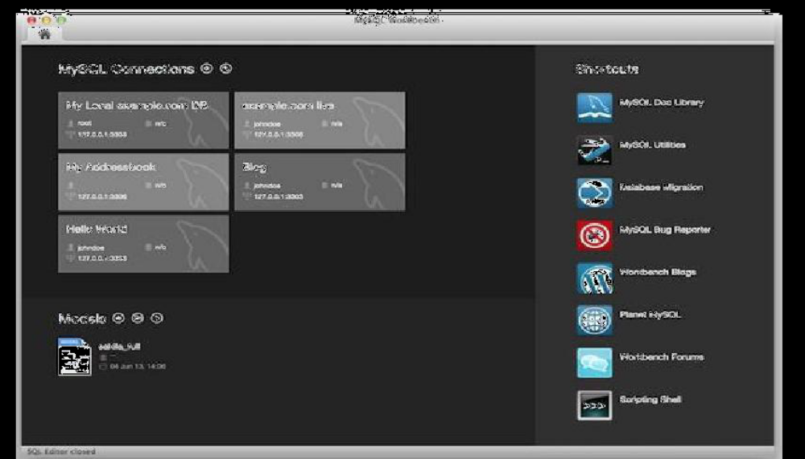

Figure 1: Workbench Home Window

2. When MySQL Workbench first starts, it presents the Home window, which has three main sections:

- List of MySQL Connections (help to manage and connect with MySQL server that actually runs the database)
- Models (facilitate database design)
- Shortcuts (quick access)

3. MySQL Workbench provides extensive facilities for working directly with SQL code. Before working directly with a live server, a connection must be created using MySQL Connections section on Home Window. After a connection is established, it is possible to execute SQL code directly on the server and manipulate the server using SQL code.

Making connection with MySQL Server

1. To administer your MySQL Server, you must first create a MySQL connection. Creating a MySQL connection is often the first action performed after installing MySQL Workbench.

2. To add a connection, click the [+] icon to the right of the MySQL Connections label on Home Window. This opens the Setup New Connection form. Fill out the connection detail as shown in Figure 2:

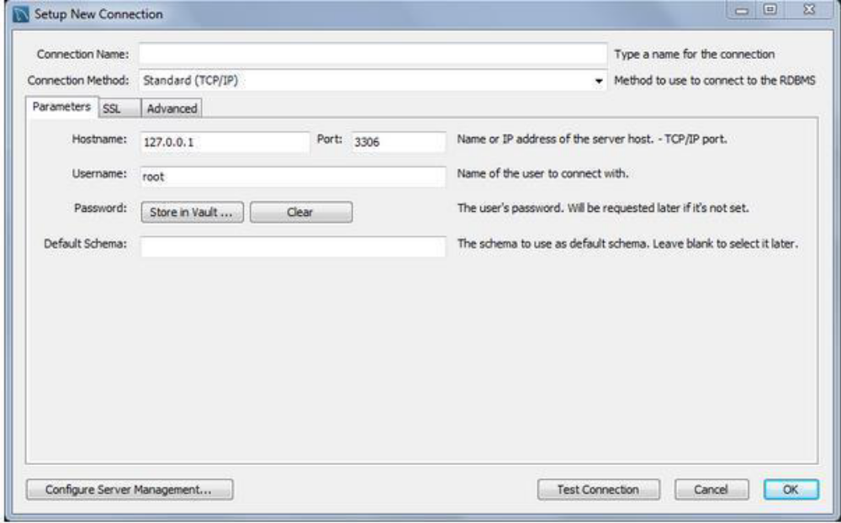

Figure 2: MySQL Server Connection Setup Window

3. Define the Connection Name value as MyFirstConnection. Click OK. The connection will appear in MySQL Connections list on Home Window.

4. Select the MyFirstConnection from Home Window, this opens the SQL Editor screen as shown in Figure 3:

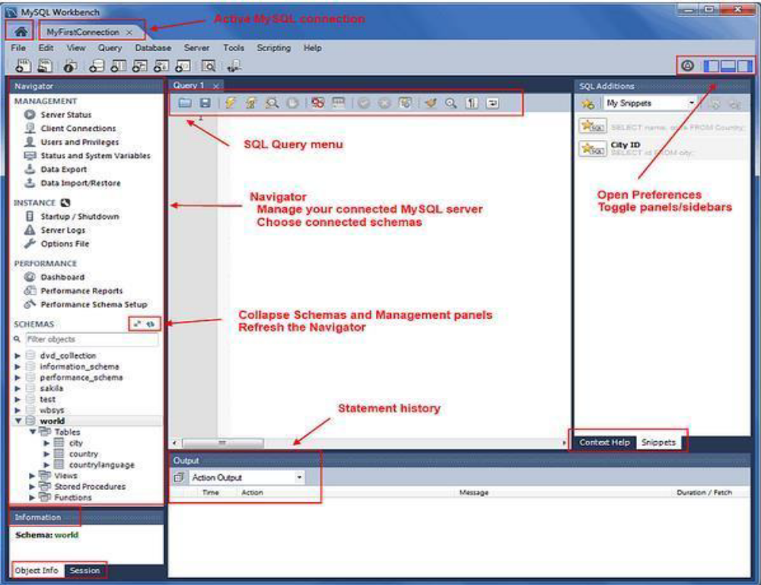

Figure 3: SQL Editor

5. For querying use SQL Query menu. It will open the SQL Query Panel as shown in Figure 4:

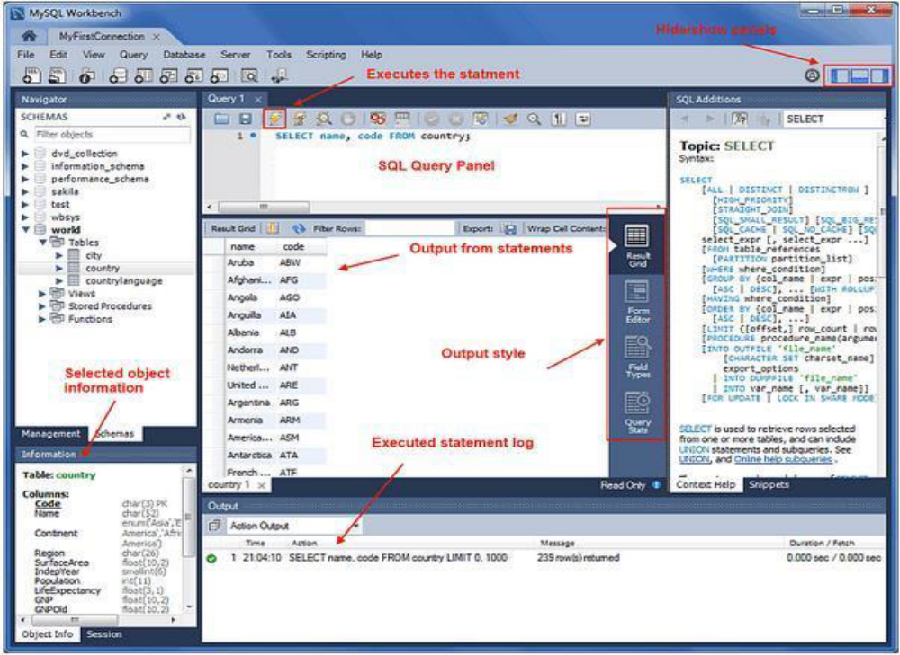
Figure 4: SQL Query Panel

Using the Sakila database

1. Download and unzip Sakila database. The archive contains three files: sakila-data.sql, sakila-schema.sql, and sakila.mwb.

2. Now right click and select drop on an existing database schema named Sakila. You will load it a fresh.

3. From File menu select Open SQL Script. Select sakila-schema.sql from the file selection dialog. It would open the file in the query pan. Now select Execute All from Query menu. You can alternatively press the Execute All icon from the toolbar. Don’t forget to check the log pan below the query tab. It mentions all errors, warnings, and messages.

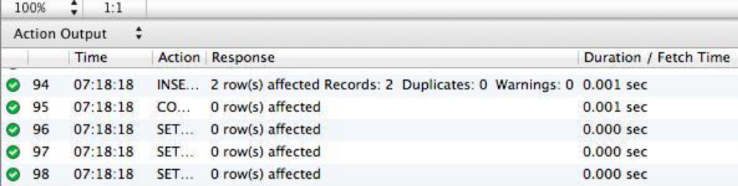

4. Press the refresh icon in the schema section . You must see Sakila database in the list of the databases.

5. Repeat the process for sakila-data.sql file. If all goes well, you have successfully loaded the sakila database and now you can close the files (but not the Workbench).

6. Expand the Sakila database. Among the listed categories, expand Tables. You will see list of tables (relations) in Sakila database.

11111111111111111111111111111111117. Right click on a table and explore the second option Table Inspector. It opens a new tab showing relation schema, attribute names and other metadata.

8. Afterwards right click on the same table and explore the first option: Select Rows. It will open another tab for navigating through the contents of the relation.

9. The data view supports many different options such as sorting on a column by selecting its header, searching contents, deleting a row, adding another, or exporting the contents to an external file. You can play with these options.

Examples:

SQL is a structure query language which is not a full featured programming language; it is only a data sublanguage, which has commands for data definition and processing. Data definition commands are Data Definition Language while data processing commands are Data Modification Language. In first lab we will focus on DML commands for which we will use Sakila Schema which we have already downloaded and is a sample data base. With the passage of time we will be able to design our own database.
When we are working on any schema, we need to set that schema as default.

Right click on sakila and select first option,“set as default schema” from menu.as shown below.

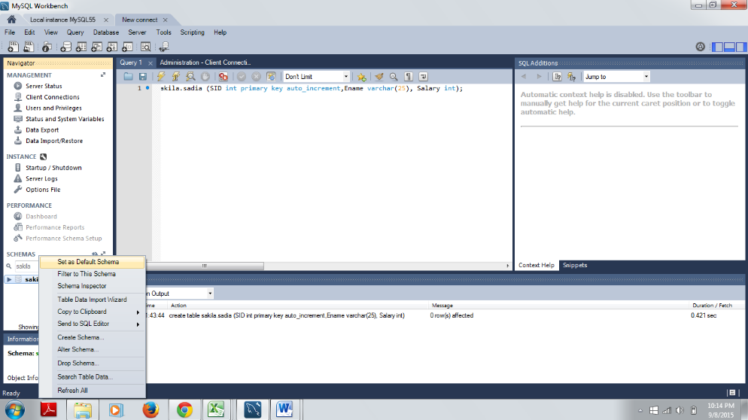

Figure 5: Setting Default Schema

Expand “Sakila”, there are further tabs as tables,views etc.Expand “Tables”.

You will find various tables including actor, class, catogory etc. All these tables have data stored. You can retrieve or update data using SQL commands.

Explore various tables of the sakila database and columns that are present in a particular table. Observe how data is stored in a table.

Retrieving Data from Tables:

When you want to retrieve some data from a table, Select statement will be most commonly used statement.
Syntax of Select statement is

Select Column name From Table name;

You can select multiple columns separated with commas or single column.

Selecting all the columns

Select * from Customers;
Selecting specific columns
Select customer name, customer id from Customers;

Example 1:
Write a query in query 1 tab.

Select actor_id from actor;

It will select actor Id column from actor table which is present in sakila database and show you the results.

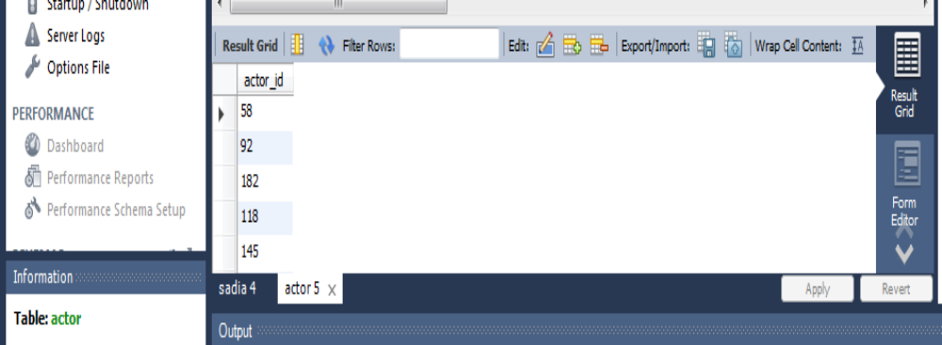

Lab Tasks
1. Write a query to Select columns “city_id” and “country_id” from the table “city” which already exists in the “Sakila” database. (Observe the output when you execute the queries.)
2. Write a query to retrieve first and last name of actors.
Deliverables
Complete your labs tasks and write queries and the steps/screenshots of all the questions attempted in a document and upload on LMS. The marking will be based on viva/lab task submitted or the quiz that takes place at the end of the lab.
Lab Rubrics

Your Lab 1 will be graded out of 5 for each rubric according to the following rubrics.

Lab Rubrics for Lab 1
Sr. No. | Assessment | Unacceptable  (0 Marks) | Does Not Meet Expectations  (1/2 Marks) | Meets Expectations  (3/4 Marks) | Exceeds Expectations  (5 Marks)
1 | Illustrating the basic understanding of syntax and semantics  (CLO1, PLO2) | The student did not submit any work.  OR  The student plagiarized the solution and/or used unfair means. | The student is unable to demonstrate an understanding of the syntax of C++ language and is unable to write an executable code.  The student is not able to understand the structure of a program at all. | The student demonstrates some understanding of C++ language syntax and can write code with few errors.  The student is able to understand the structure but still learning the syntax. | The student demonstrates a good understanding of the syntax of C++ language and is able to write executable code without help  The student is able to understand the structure and is able to identify problems in the code  when introduced
2 | Software Tool Usage  (CLO3-PLO5) |  | The student demonstrates a lack of understanding of tool usage.  Implementation has syntax/semantic/runtime errors, and the student is unable to debug and correct the errors.  The code has inadequate comments and variable names and does not adhere to the coding standards.  No Error handling has been performed.  Documentation is poorly structured. | The student demonstrates some understanding of tool usage.  The codes are correct in terms of their syntax; however, the program output is not always correct in all test cases.  The code has limited comments and inconsistent variable names and may not adhere to the coding standards.  Some Error handling has been performed.  Documentation is adequately structured. | The student demonstrates a good understanding of tool usage.  Furthermore, his/her coding is complete and functional, and the program output is correct in all test cases.  The code has sufficient comments and consistent variable names and reasonably adhere to the coding standards.  Adequate Error handling has been performed.  The documentation is well structured.

